 |  |  |  | Document-141906

Design Note TRI-DN-17-08

BL1U Beam Current Interlock Requirements
Document Type: | Design Note
Release: | 1 | Release Date: |  |  | 2017-06-20
Author(s): | Thomas Lindner
 | Name: | Signature: |  |  |  | Date:
Author: | Thomas Lindner | Approval Routing
Reviewed By: | Anne Trudel
 | Cam Marshall
 | Chuck Davis
Approved By: | Ruediger Picker
Note: Before using a copy (electronic or printed) of this document you must ensure that your copy is identical to the released document, which is stored on TRIUMF’s document server.
History of Changes
Release Number | Date | Description of Changes | Author(s)
1 | 2017-06-20 | Initial Version | Thomas Lindner

Keywords: BL1U, Beam Line 1U

Distribution List: Victor Verzilov
Iouri Bylinskii
Juan Pon
Gelo Ramon
Rod Nussbaumer
John Drozdoff
Beatrice Franke

Abstract
This document will lay out the requirements for an interlock system based on the average BL1U beam current measurements. This interlock system is required to satisfy both machine protection and regulatory requirements. We envision that the main beam current measurement will be made with the Toroidal Non-Intercepting Monitor, B1U:TNIM2; but this document will not deal with the details about how this device will be used to meet the requirements.
BL1U:TNIM2

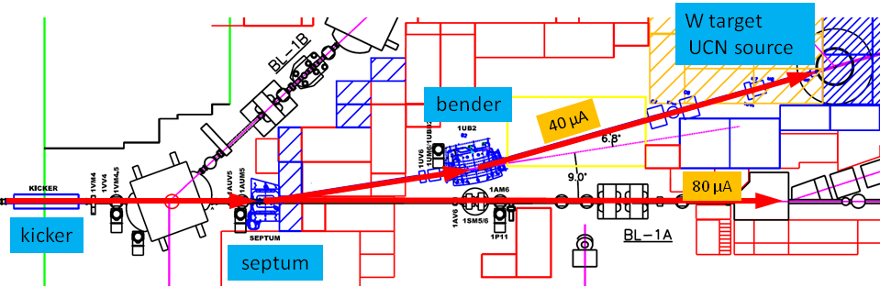

Figure 1: overview of the beamline 1U. The UCN kicker magnet is on far left. The Toroidal Non-Intercepting Monitor, B1U:TNIM2 is shown on the right, just before the BL1U target.

Introduction
An overview of the beamline 1U (BL1U) is shown in Figure 1.

The beam from the cyclotron is delivered in ~1 ms “buckets” separated by shorter periods where the beam is blanked by the ion source pulser. During normal UCN operation the blanking interval will be required to be 50 μs or longer (normally in the range 50 μs to 100 μs). Beam sharing between beamline 1A and beamline 1U will be done by deflecting a certain fraction of the beam buckets to BL1U. In figure 2, we show a 2:1 splitting, where 1 bucket is deflected to BL1U, 2 buckets allowed to pass undeflected, and so on.

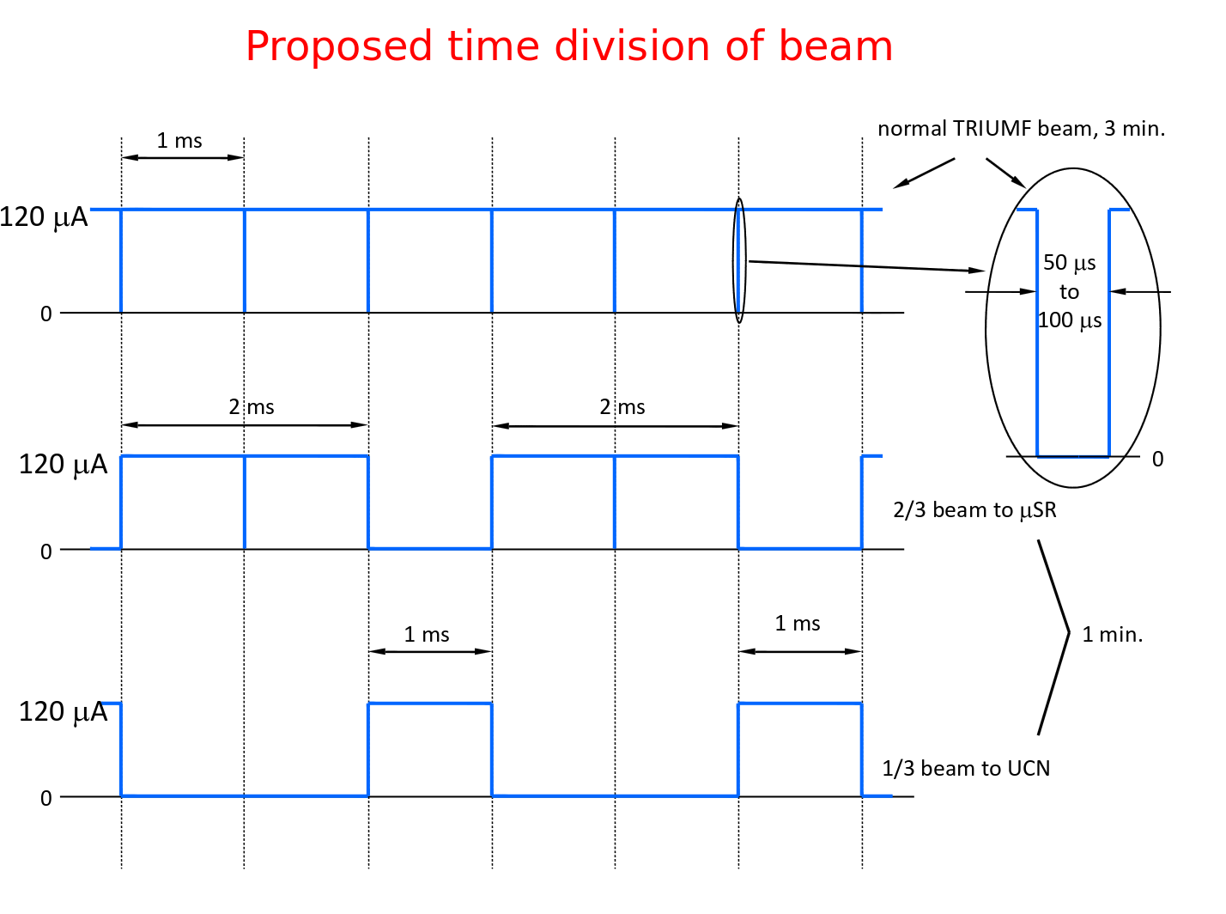
Figure 2: scheme for dividing beam between beamline 1A and 1U. 1V beam is divided into 1ms buckets with blanking notches between. This diagram shows the final configuration where 1/3 of beam buckets go to 1U. The kicker magnet must ramp up and down within the blanking notches.

To deflect a beam bucket to UCN, the kicker magnet (1VKICK) ramps up during the 50 μs blanking interval, deflects the 1ms bucket to the UCN beamline, then ramps down again in the 50 μs blanking interval following the beam bucket.

We note several further points about the BL1U beam:
- UCN beam will be delivered in two different modes:
  - DC mode: with the UCN kicker magnet permanently on, all beamline 1V beam is directed to BL1U. In this mode the beam current to BL1U will be limited either at the cyclotron source or by some sort of stripper foil shadowing.
  - Kicking mode: UCN kicker magnet will kick a fraction of the 1ms proton buckets to BL1U; other buckets will be delivered to 1A targets. This will be the more common mode of operation, at least in the longer term. In order to deliver 1uA of beam to UCN in kicking mode, one 1ms bucket of beam would be directed to BL1U, followed by 119 1ms buckets going to 1A beamline (assuming 120uA of beam down BL1V). So for 1uA of average current, BL1U would have an effective duty cycle of ~0.8%; only getting beam for 0.8% of the time.
- The average BL1U beam current will be anywhere between 1-40uA. For early running (certainly in 2017) beam current will be limited to 1uA (our current CNSC license only allows for 1uA). In the following years the beam current will gradually be increased.
- In 2017 our limit on the beam current will be 1uA. We may, therefore, need to run at slightly less than 1uA; for the purposes of meeting the requirements in this document, we would assume that we want to run at 0.9uA or higher.
- In kicking mode, the BL1U beam current on a sub-millisecond timescale will be either 120uA and 0uA (as seen in Figure 2). However, for the purposes of machine protection and regulatory compliance, measuring the beam current on the sub-millisecond timescale is not helpful. Instead it is better to define an average beam over several of the kicking cycles. For instance, for the 1uA beam we put 120uA beam onto target for 1ms and then have no beam for 119ms; so a relevant timescale for averaging is at least 120ms. Since we may want to run at even lower beam current in kicking mode, let us say that the relevant timescale for averaging is 500ms. So, for the purpose of this document, let us define the following: the average BL1U beam current in kicking mode is the beam current averaged over 500ms. This average BL1U beam current is the relevant quantity for the machine protection and regulatory requirements, as shall be described in the following sections.

Requirements for BL1U Beam Current Interlocks
We require an interlock system based on the average BL1U beam current for both machine protection and regulatory reasons. We explain below both the reason and the timescale for these interlocks.

Machine Protection
The primary machine protection risk from a situation where the beam current is too high is a failure of the beamline exit window or the target entry window. The UCN beamline is designed for an average beam current of 40uA; but that final design power will require a raster magnet for spreading the beam spot size across the target. This raster magnet is not currently installed. See design notes TRI-DN-15-27 and TRI-DN-14-17 for details on the UCN beamline final leg and UCN target.
For the moment, the UCN beamline windows can operate safely for an average beam power up to 10uA; see the thermal stress studies of the beam exit window that were done in TRI-DN-14-17 for details. If the average beam power exceeds 10uA the cyclotron should be tripped; the trip should happen in a time that is shorter than 1 second.

Regarding the timescale: if the full 120uA is put down BL1U, then the beamline exit window should take more than 1 second before it reaches its plastic deformation temperature. Project engineer Cam Marshall needs to do a more detailed calculation to see the exact length of time before the windows is damaged. But a 1 second timescale to trip should be conservative.

Regulatory Requirements
Our CNSC license will require that the average current down BL1U is less than or equal to 1uA (for 2017). Based on other TRIUMF facilities, it seems that this regulatory requirement can have a timescale of minutes. Our requirement will therefore be that:
- the average beam current be less than or equal to 1.5uA on a 10 second timescale
- the average beam current be less than or equal to 1.0uA on a 10 minute timescale
If either of these requirements is not met, then a beamtrip must be generated.
We note that the machine protection requirement will already ensure that the beam current not exceed 10uA in a 1 second timescale.

Summary of Present Interlock Requirements
- For machine protection reasons, we require that we be able to trip the cyclotron in less than 1 second if the average beam current exceeds 10uA.
- For regulatory reasons, we require that we be able to trip the cyclotron:
  - in less than 10 seconds if the average beam current exceeds 1.5uA.
  - in less than 10 minutes if the average beam current exceeds 1.0uA.
- These interlocks should work with the UCN beamline in either DC mode or kicking mode.

Future Beam Current Interlock Requirements
In the previous section we have listed the requirements for the beam current interlocks at the present time. In the future we plan to increase the UCN shielding in order to be able to have CNSC licensing to run at higher beam currents. We will therefore need to have higher trip points in our beam current interlocking system. However, the main challenge of developing this interlock system is having B1U:TNIM2 electronics and digitization that is sufficiently precise to be able to trip at the low beam currents listed above; so we hope that any system that we develop to be able to meet the present beam current interlocks will be sufficient as we push to higher beam currents.

References
TRI-DN-14-17 UCN beamline final leg
TRI-DN-15-27 Detailed Design of the UCN target and Extraction Mechanism
TRI-DN-16-11 UCN kicker control system

Note that the beam notches actually come at a rate of 1.1kHz, not 1kHz, so the actual width of the buckets is 0.91ms. But for simpler text I will keep referring to the bucket as being 1ms long.
The actual length of the blanking notch will depend on the stability and cleanliness of the notch.

